Project Report

On

# Heart Attack Prediction

Submitted by

Athul P.

# Abstract

Health care field has a vast amount of data, for processing those data certain techniques are used. Machine Learning is one of the techniques often used. Heart disease is the Leading cause of death worldwide. This System predicts the arising possibilities of Heart Disease. The outcomes of this system provide the chances of occurring heart disease. The datasets used are classified in terms of medical parameters. This system evaluates those parameters using Machine Learning technique.

Index

|  |  |  |
| --- | --- | --- |
| S no. | Title | Page no |
| 1. | Introduction | 3 |
| 2. | System Implementation | 4 |
| 3. | References | 13 |
|  |  |  |
|  |  |  |
|  |  |  |
|  |  |  |
|  |  |  |
|  |  |  |

# Introduction

Heart disease is the major cause of morbidity and mortality globally: it accounts for more deaths annually than any other cause. According to the [WHO](https://www.who.int/health-topics/cardiovascular-diseases/" \l "tab=tab_1), an estimated 17.9 million people died from heart disease in 2016, representing 31% of all global deaths. Over three quarters of these deaths took place in low- and middle-income countries.

Of all heart diseases, coronary heart disease (aka heart attack) is by far the most common and the most fatal. In the India, for example, it is estimated that someone has a heart attack every 90 seconds and about ****80,000 Americans****have a heart attack every year .

The silver lining is that heart attacks are highly preventable and simple lifestyle modifications(such as reducing alcohol and tobacco use; eating healthily and exercising) coupled with early treatment greatly improves its prognosis. It is, however, difficult to identify high risk patients because of the multi-factorial nature of several contributory risk factors such as diabetes, high blood pressure, high cholesterol, et cetera. This is where machine learning and data mining come to the rescue.

## System Implementation

## 1.Screenshot streamlit dashboard

a.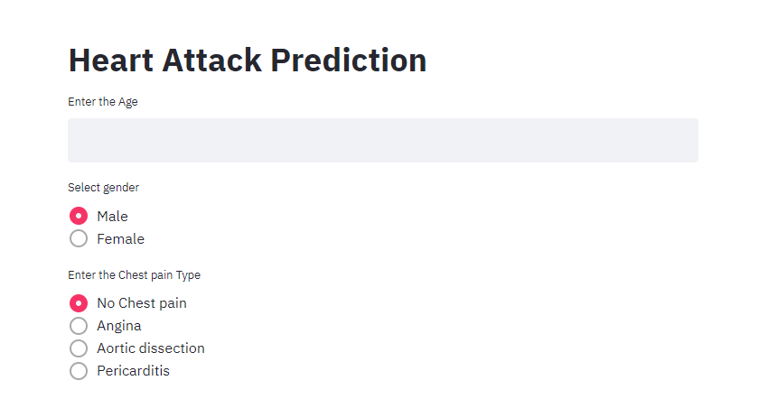

b.

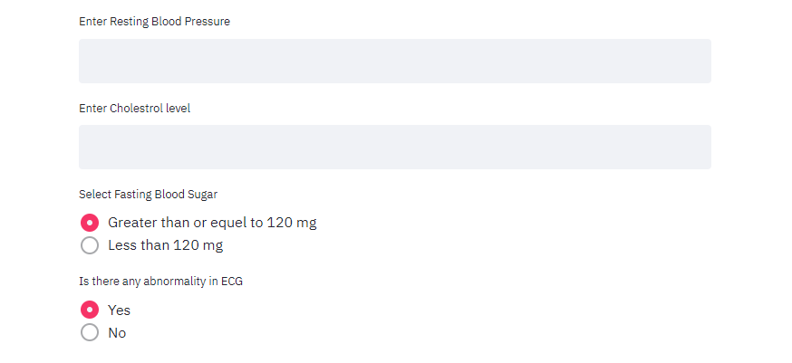

c.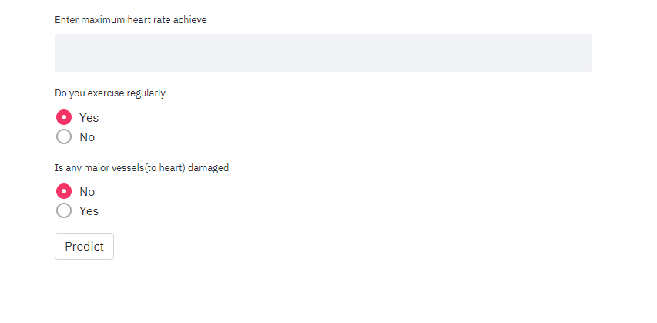

References

1. [https://www.tutorialspoint.com](https://www.tutorialspoint.com/python/python_gui_programming.htm)
2. <https://www.maxhealthcare.in/our-specialities/cardiology/conditions-treatments/heart-attack>
3. <https://stackoverflow.com/>